**VISVESVARAYA TECHNOLOGICAL UNIVERSITY**

"Jnana Sangama", Belagavi: 590 014, Karnataka.

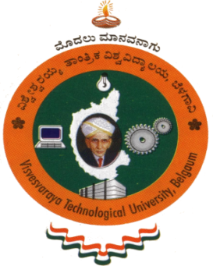

A Project Report on

**“MEDIA PLAYER APPLICATION”**

A Dissertation work submitted in partial fulfillment of the requirement for the

award of the degree of

**Bachelor of Engineering**

In

**Computer Science & Engineering**

**Submitted by**

**VINODKUMAR SANKRANTHI**

**(3SL19CS055)**

Under the guidance of

**PROF. R.K ASHWIN**

**Assistant Professor**

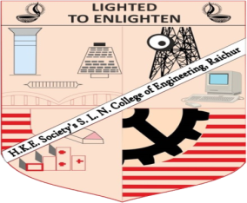

**DEPARTMENT OF COMPUTER SCIENCE & ENGINEERING**

**H.K.E Society’s S.L.N. COLLEGE OF ENGINEERING   
(Affiliated to VTU - Belagavi, Affiliated to AICTE – New Delhi, Accredited by NAAC)**

Y-Camp, Raichur-584 135, Karnataka

**2021-2022**

**VISVESVARAYA TECHNOLOGICAL UNIVERSITY**

"Jnana Sangama", Belagavi: 590 014, Karnataka.

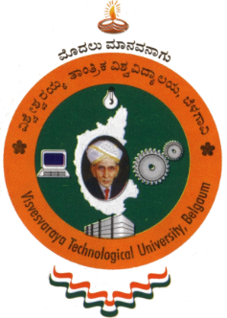

**H.K.E Society’s S.L.N. COLLEGE OF ENGINEERING**

**DEPARTMENT OF COMPUTER SCIENCE & ENGINEERING**



**CERTIFICATE**

Certified that the project work entitled **“MEDIA PLAYER APPLICATION”** is a bonafide work carried out by VINODKUMAR SANKRANTHI (3SL19CS055), has been successfully presented at H.K.E.SOCIETY’s SLN COLLEGE OF ENGINEERING in partial fulfillment for the award of degree of **Bachelor of Engineering in Computer Science** **Engineering of Visvesvaraya Technological University,** Belagavi during the academic year **2021- 2022**. It is certified that all the corrections / suggestions indicated for the internal assessments have been incorporated in the report deposited in the department. The project report has been approved as it satisfies the academic requirements in respect of project work prescribed for the **Bachelor of Engineering Degree**.

**Signature of the Guide Signature of the HOD Signature of the Principal**

**(Prof. R.K ASHWIN) (Prof. SUMANGALA.I) (Dr. BASAVARAJA)**

**Name of the examiners Signature with Date**

**1.**

**2.**

**ACKNOWLEDGEMENT**

This satisfaction and euphoria that accompany the successful completion of any task would be but incomplete without the mention of the people who made it with constant guidance and encouragement and crowned our efforts with success.

We would like to express our gratitude to our Principal **Dr. R. BASAVARAJA**, H.K.E Society’s S.L.N. College Of Engineering, Raichur for providing a congenial environment and surroundings to work in during our entire course.

A heartly thanks to our beloved HOD, **Prof. SUMANGALA. I,** Department of Computer Science & Engineering, for valuable support and Guidance.

We express our sincere thanks to our beloved Project Guide **Prof. R.K ASHWIN,** Department of Computer Science & Engineering, for his constant encouragement and support throughout our course, especially for the useful suggestions given during the course of the project period.

We also thank all the staff members of Department of Computer Science & Engineering, and all those who have directly or indirectly helped us with valuable suggestions in the successful completion of this project.

Last but not the least we would like to thank our beloved parents and our friends for their blessings, love and encouragement to successfully complete the task by meeting all the requirements.

**VINODKUMAR SANKRANTHI**

**(3SL19CS055)**